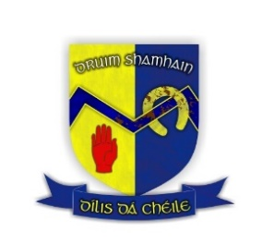

CRUINNIÚ BLIANTÚIL DRUIM SHAMHAIN (2023/2024)

(Drumhowan Annual General Meeting)

AINMIÚCHÁIN
(Nominations)
(To be returned on, or before, (30th November 2023)

Oifig/Officership/Position: | Ainmniúcháin/Nominee:

Cathaoirleach/Chairperson
Leas-Chathaoirleach/Vice-chairperson
An Rúnaí/Secretary
An Rúnaí Cúnta/Assistant-Secretary
Cláraitheoir / Registrar
An Cisteoir/Treasurer
An Cisteoir Cúnta/Assistant-Treasurer
Oifigeach Arachais /Insurance Officer
Oifigeach Coitseala /Coaching Officer

Oifigeach Forbartha / Development Officer
Oifigeach Club Slaintiúil /Healthy Club Officer
C.P.O / P.R.O.
Ionadaí na nImeoirí/Players Representative
Ionadaí don Bhord Condae/ County Board Delegate
Oifigeach Gaeilge agus Cultúr/ Language & Culture Officer | Appointed on the recommendation of the outgoing Executive Committee - not an elected position
Oifigeach na Leanaí/Children’s Officer  Oifigeach Oige/ Youth Officer | Appointed on the recommendation of the outgoing Executive Committee – not an elected position
An Coiste/Committee

Sínithe/Signed: ___________________________________

